Philip was born on 19 July 1920 in Newcastle-upon-Tyne to Lithuania born parents Barnett and Sylvia nee Finklestone and he had eight siblings.
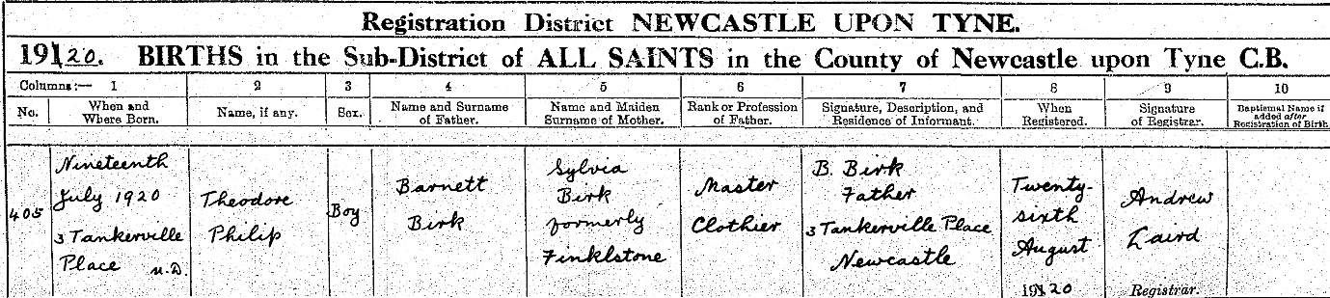Barnett was previously married to Sylvia's sister Sarah, and they had two children Dora and Arnold. Sarah died on 7 November 1912 just three years after they married in Leazes Synagogue in Newcastle-upon-Tyne.
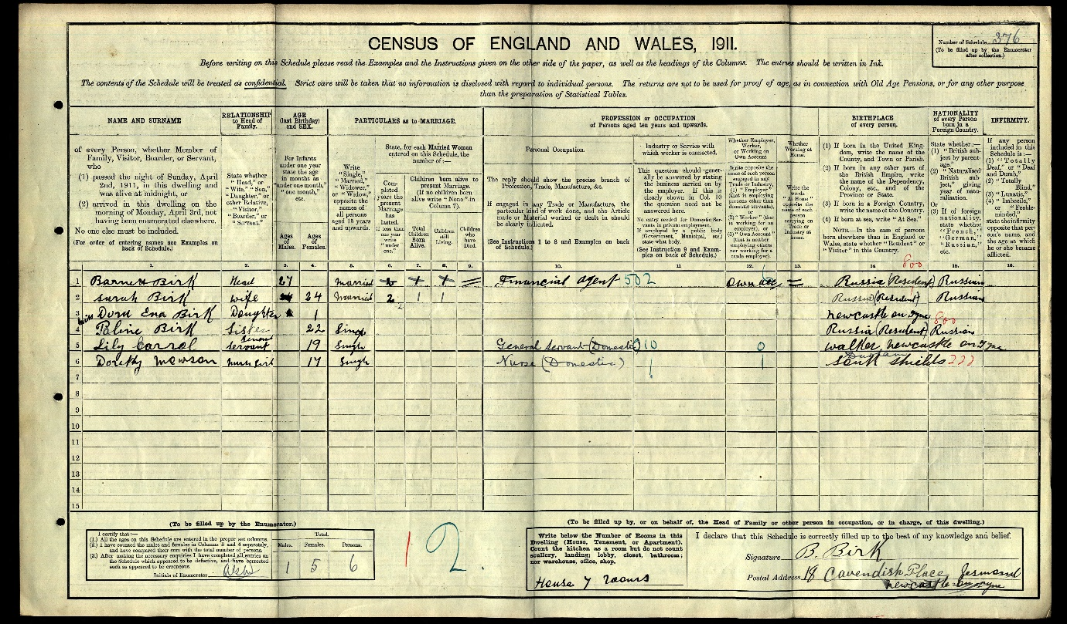
1911 Census. Barnett, a financial agent, was married to Sarah.
Barnett then married Sylvia one year later on 25 December 1913 at Brondesbury Synagogue in London.
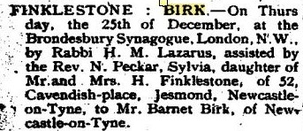Jewish Chronicle Marriage Announcement
They went on to have five children, Rita, Ellis, Gladys, Ena and finally Philip in 1920, all born in Newcastle.
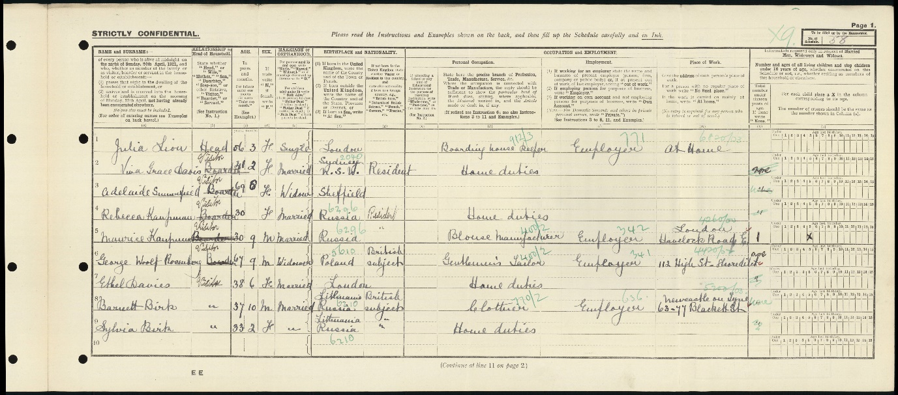
The 1921 Census shows Barnett and Sylvia on holiday at 1 Trinity Place, a boarding house in Eastbourne.
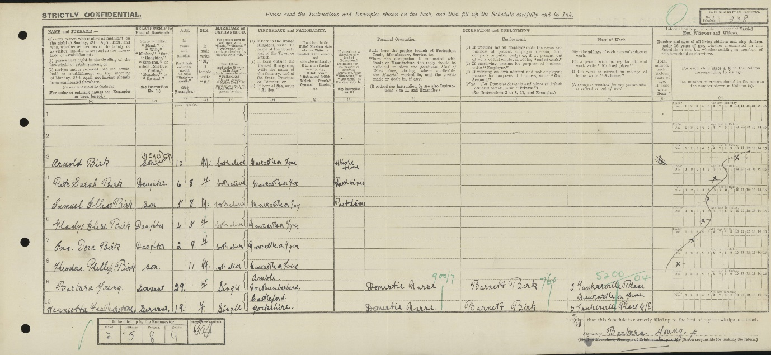
In 1921, the children remained at home with servants at 3 Tankerville Place, Newcastle-upon-Tyne
Tragically, Sylvia died on 29 December 1921, seventeen months after Philip's birth and is buried in the Jewish section of Elswick St John Cemetery in Newcastle. She was travelling on the train from York to Manchester on her way to meet with Barnett and Philip at Blackpool. She was seen to put down the book she was reading and without rising take hold of the inside handle of the carriage door. The handle turned, and the door flew open, and she shot out with it, falling on the line headfirst. A verdict of accidental death was given.
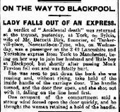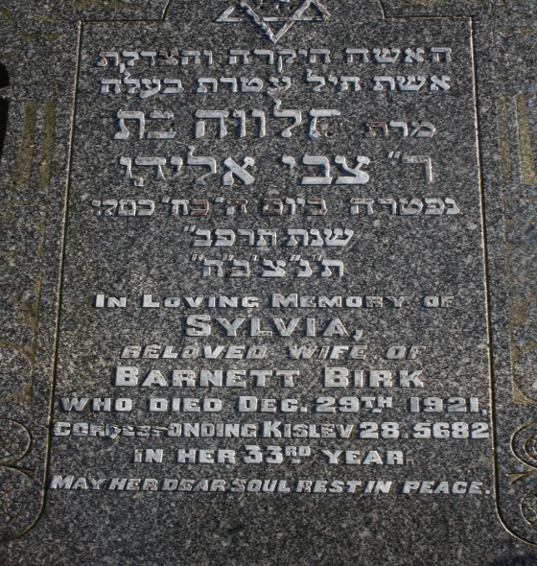
Barnett worked as a clothier, a financial agent and a company director and married for the third time in 1923 to Daisie Cohen, a hospital almoner. They then had a daughter Pamela the following year.
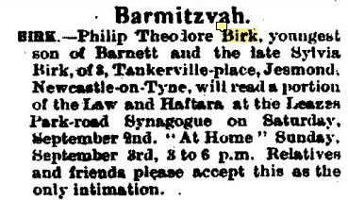
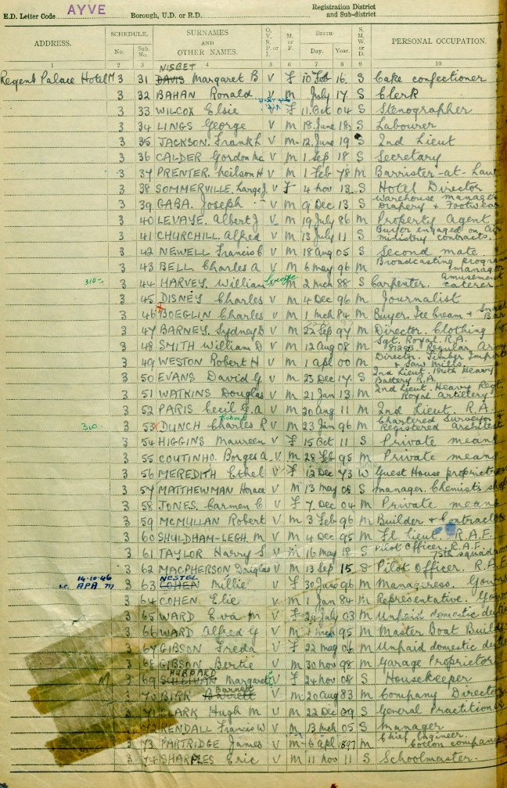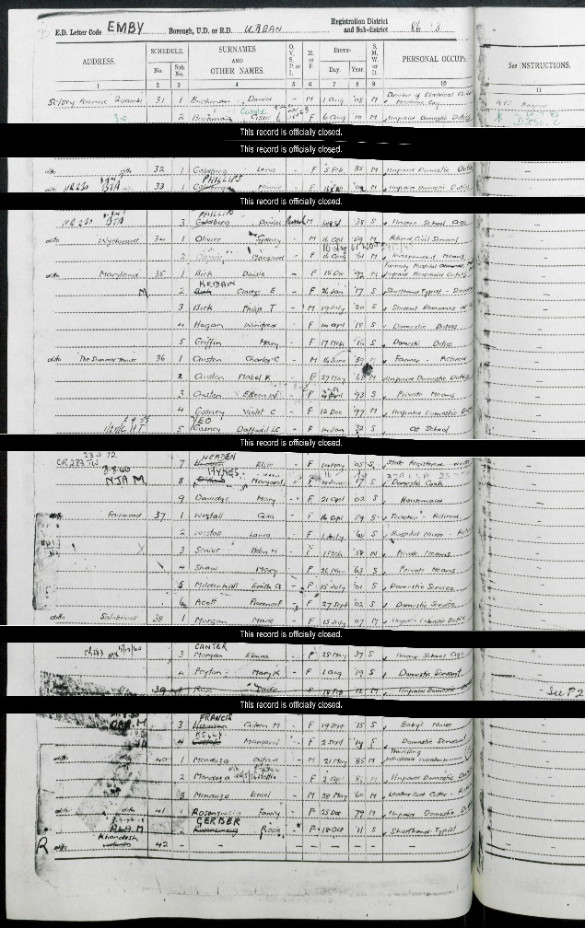
The 1939 Register lists Barnett as staying at the Regent Palace Hotel, London and Philip is listed as staying with his stepmother Daisie at Selsey Avenue, Bognor Regis. Philip is listed as an economics student.
Barnett, a wealthy man, died on 22 September 1943 at 'Sunningdale', The Bishops Avenue, Hampstead and his obituary described him as: One of the founders and at the time of his death Warden of the Hampstead Garden Suburb Zionist Society. Before he moved to London, he was a prominent communal and Zionist worker in Newcastle. He is buried at Willesden Jewish Cemetery.
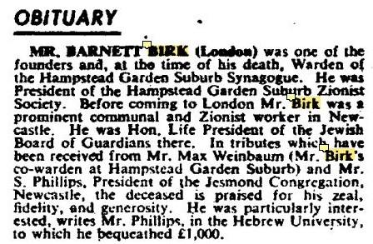
Philip enlisted on 6 January 1943 and was sent for training in Ashford, Kent in July 1943. On 13 January 1941 he was commissioned and his records list him as a Regular Army Emergency Commission with the rank of 2nd Lieutenant.
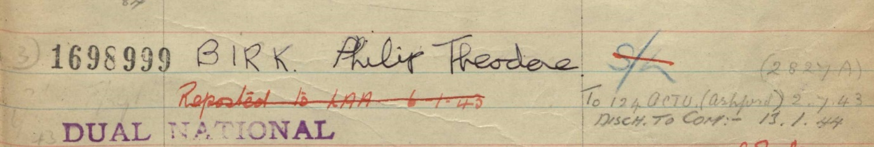
Philip survived the war in Burma fighting with the 14th Army without any injuries and his family were shocked to receive a telegram informing them of his death. The family were advised that he died as a result of an accident but his stepmother Daisie uncovered the fact that he was on a night time secret patrol when he was killed.
